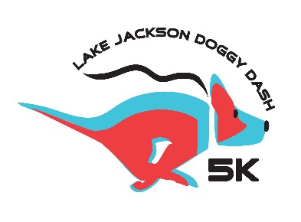
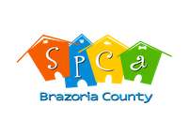
Dear Fellow Animal Lover,
The Lake Jackson Doggy Dash 5K is excited to announce this year we are collaborating directly with SPCA-BC to combine formerly two separate events into one fun-filled day, The Lake Jackson Doggy Dash (LJDD) 5K followed by Bark in the Park! Our goal is simple – to gather together members of our community and support the SPCA-BC with their mission as a no-kill organization to promote responsible pet ownership in order to prevent animal cruelty and abandonment.
The LJDD and Bark in the Park teams need your help to continue to learn and grow this event. All proceeds from this year’s event held on Saturday March 2nd, 2019 will help offset the costs of organizing the race and raise money to provide food, medicine, and other ongoing shelter needs for the Southern Brazoria County Animal Shelter.
Please help make this event a fundraising success by becoming an official event sponsor!
Official Event Sponsor
- Please see attached sponsorship levels & email spcabcboard@gmail.com with the registration form
- All sponsors will be acknowledged on the race t-shirts, race pamphlet, race banner and other advertisement campaigns (e-mail, website, Facebook, etc.) if received by February 8th, 2019.

The LJDD and Bark in the Park planning team would like to thank you again for your help with this year’s race and event. We are looking forward to this year’s combined event and continuing our support of the SPCA of Brazoria County and the wellbeing of all of our furry friends.
Sincerely,
The LJ Doggy Dash and Bark in the Park Planning Team
Julie Baron
Beate Damm
Alexia Finotello
Amanda Geither
Brandei Goolsby
Erica Ledesma
ljdoggydash@gmail.com
spcabcboard@gmail.com

